WHITE PAPER ON ALTERNATIVES FOR WASTEWATER MANAGEMENT IN THE GREAT FALLS COMMERCIAL CENTER
Purpose-
The purpose of this paper is to present information on an issue of importance to the community of Great Falls; the issue is how to provide long term reliable wastewater management in the Commercial Center of Great Falls, whether it be a continuation of conventional septic systems, replacement by either advanced technology septic systems, or installation of a sewer line from the Commercial Center to the Fairfax County sewer system.

Historical Background-
The Great Falls Commercial Center developed over the past 40-50 years, and comprises those small town businesses and public facilities near the vicinity of Georgetown Pike and Walker Road. Sewer service was not available nearby, and so the businesses installed conventional septic systems for wastewater management. The commercial area is essentially fully developed. The commercial development occurred at the beginning of the time frame that the residential growth of the surrounding community began to rapidly occur. Historically, the community has desired to maintain a semirural and small town nature. There has also been a concern that in other parts of Virginia, waterlines and sewer lines installed in relatively undeveloped areas have lead to pressure for more dense development.

Similarly, there has been an ongoing relationship of the Community with the Commercial center of Great Falls, in which the types of business are those that serve the local community, and these are typically offices, restaurants, and retail stores frequented by local residents, not national chains typical of regional malls. Similarly, local businesses and the growing number of civic-minded groups have cooperated to produce a wide range of community-wide functions that maintain and enhance this small town atmosphere. In an opinion poll in 2007, it was determined that residents desire to maintain the small town cohesive nature of Great Falls.

At the present time there are about 5700 homes and 16,000 residents in Great Falls, and nearly all the developable land has been developed in large lot subdivisions. Public water is generally available South of Georgetown Pike, and not available North of Georgetown Pike. Public sewer and water are both available at the other two Commercial areas in the Community, near Colvin Run Road/Walker Road, and Georgetown Pike/Seneca Road.

So, an important issue from a historical perspective is whether installation of a sewer line in the Great Falls Commercial Center would alter the desired small town character, and whether the Board of Supervisors can define the Sewer District with adequate controls to avoid unwanted expansion.

Past Difficulties with Septic Systems-
About 2005 or earlier, the Great Falls Business and Professional Association raised the potential for failures of the septic systems in the Commercial Center, and the negative effects this could have on the long-term viability of businesses. There have been several significant problems with septic field failures over the years, and this resulted in a need for pumping and hauling raw wastewater in tanker trucks through the center of town, while expensive repairs and maintenance were conducted. At the present time, two of the septic fields are failed and cannot be repaired. Fairfax County recently spent $1 million to buy a 1-acre parcel on Walker Road to install a septic system for the new Great Falls Fire Station, since the drain field became plugged and there was no reserve area.

About 10 years ago BPA began to study the possibility of planning to install a sewer line that could more reliably manage wastewater for the future. Because of past public concern about waterlines and sewer lines, they recognized that elected officials may not be likely to authorize a sewer line without substantial public support. In 2010, the Great Falls Citizen’s Association reestablished its Wastewater Subcommittee to conduct a series of informative public meetings. The intent is to develop and present publicly, credible information on the alternatives to the status quo for future wastewater management in the Commercial Center of Great Falls. It is intended that a factual presentation on all the issues will lead to a better-informed choice of a preferred alternative, by the greater Great Falls Community. The Great Falls Citizens Association does not feel it is desirable to wait for a significant septic field failure to occur, but wants the Community to approach this issue calmly before an emergency situation occurs. The alternatives examined are:

A continuation of the status quo,
A conventional sewer line,
An advanced technology sewer line, or
Advanced pretreatment technology with onsite disposal

Wastewater Seminar Series-
At the beginning of this effort, Mr. John Foust, Dranesville District Supervisor, provided assistance to the Great Falls Citizens Association, in arranging for help from senior individuals in key Departments of Fairfax County. In four
Town Hall Meetings sponsored by GFCA, highly experienced County and Corporation personnel presented information on each of these alternatives. There was also a quantitative analysis presented of the potential that a sewer line might stimulate higher incremental density in the Commercial Center, as well as information on controls to limit use of the sewer line to only intended areas.

Update of Septic System Performance, the Status Quo Alternative
At the September 14, 2010, meeting of the Great Falls Citizens’ Association, the Fairfax County Health Department, Mr. John Milgrim, Mr. Martin Thompson, and Mr. Martin Shannon presented an updated assessment as of 2010, of the performance of the 22 septic systems in the Commercial Center, indicating that problems continue to occur, due to failure to pump septic tanks or switch diversion valves always on the required frequency, failure of grease traps and resultant coating of underground distribution surfaces, or entry of roots of trees and bushes into septic field distribution lines, or just aging systems becoming filled with suspended solids.

The distribution fields are somewhat wetter than reported in 2005. There are also considerable ongoing maintenance problems with these older systems, and it is difficult to obtain spare parts in some instances. It is expected that problems will continue and could result in failure of one of the large systems at some point in the future, requiring pumping and hauling on a larger scale. There is also an odor of sewage water in some areas, and is very undesirable in a public area. A Health Department map below shows in yellow that many are not percolating very well. In conclusion, while use of the current septic systems may acceptably continue over the near term, the long term continued use is not considered acceptable, and action should be planned to install a long-term reliable alternative.

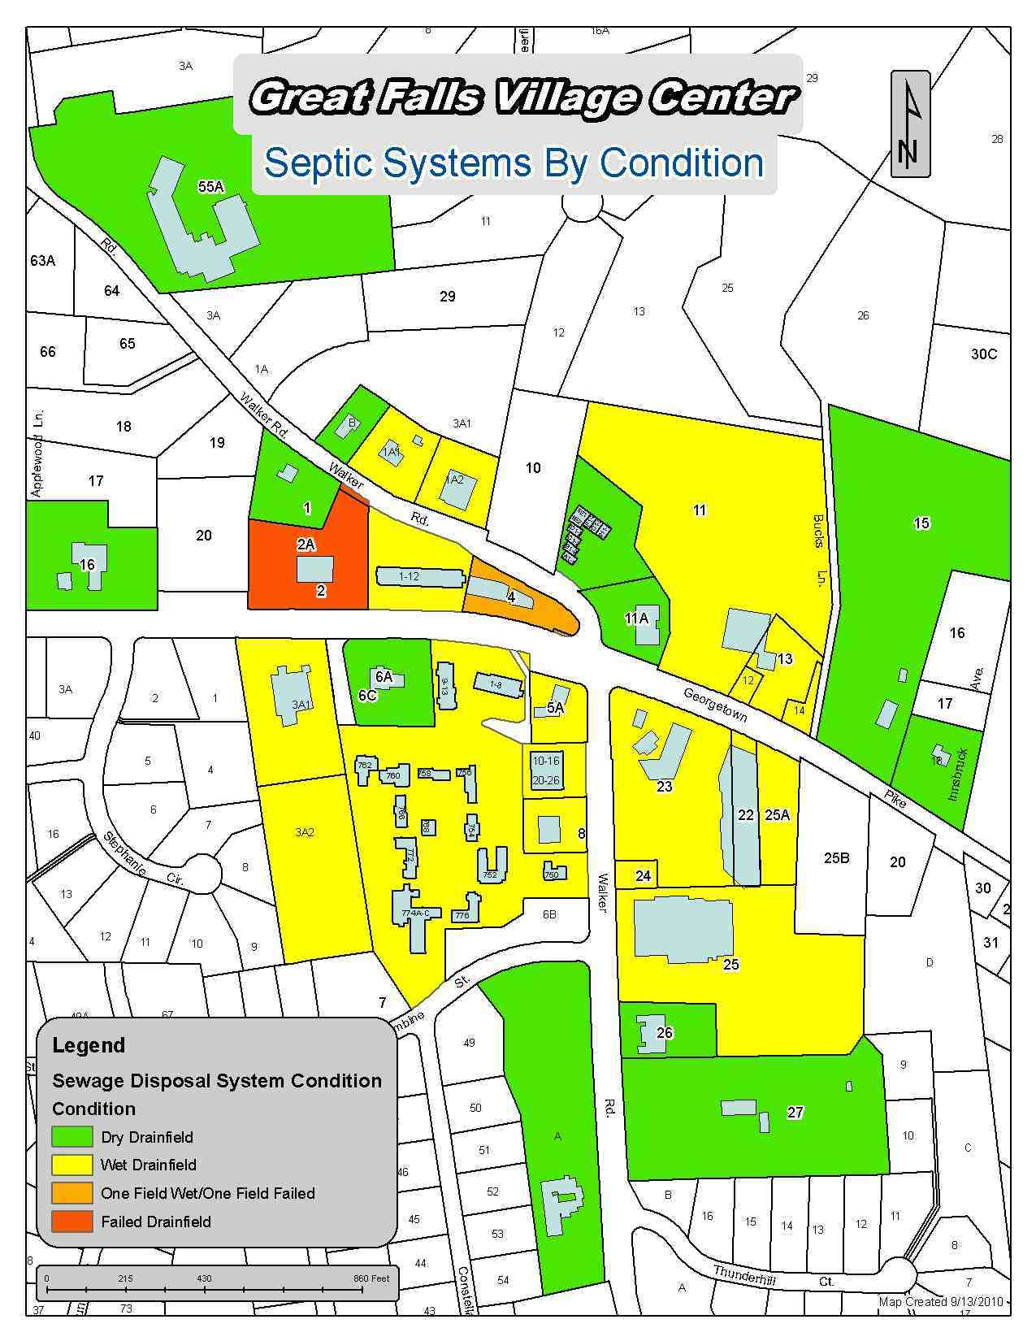

Traditional Fairfax County Sewer Line Alternative:

In this alternative, the Fairfax County Board of Supervisors would first establish a Sewer District, in accordance with County procedures and ordinances. Sharam Moshenin and Ahmed Rayyan presented a possible Sewer District, which includes the businesses and the Government facilities in the Great Falls Commercial Center, near the intersection of Walker Road and Georgetown Pike. The legal definition of the District would be prepared so as to limit access to the sewer line to only the land within the District.

The system would use a PRESSURIZED force main about 4-6 inches in diameter from the edge of the Sewer District, buried below the frost line, running to the existing County Sewer System. The sewer line would NOT be a gravity-drain system, because this would go down stream valleys, and cause damage, and be longer and more costly. With the use of a Pressurized main, it would therefore be unlikely that a connection would be feasible along the main. This line would be sized to handle the total volume generated by the Commercial District, currently about 40,000 gallons per day.

The shortest of three routes studied would be about 2 miles down Walker Road to the existing sewer system at Colvin Run Road. In the traditional sewer line alternative presented by the Department of Public Works and Environmental Services, wastewater would be pumped from each business or public facility through a collection system to a large collection tank at the edge of the Sewer District. From there, a large lift pump would transfer it to the existing sewer line near Colvin Run Road.

The conceptual Sewer District presented by the County staff is shown below:

Possibility of Additional Hookups:
It has been postulated that a landowner of residential property near the Sewer District might seek to obtain a connection to the sewer line to include his property. This would be subject to the County ordinances, and probably would not be approved. One provision under which a hookup is possibly permitted within 300 feet is for a hardship condition if a septic system failure occurs, and no onsite remedial action is feasible. It is not known how likely such a request is, but the mere possibility indicates why it is important that the definition of the sewer district be strictly constructed if the Community is intent on preventing it.

Users are Responsible for Cost-
The cost of the sewer line would be the responsibility of the landowners within the Sewer District, consistent with County Policy. The landowners could fund the design and construction or the County could be requested to consider a Bond for initial construction, but would recoup the cost from landowners. It was felt that there could be a logical sharing of the cost by the commercial businesses and the 6 Government facilities, including the Great Falls School, the Fire Station, the Library and Grange and old School House, and the Post Office. Initially, the cost was estimated at $7.5 million, based on installation down the center of the road, but subsequently, it was determined that there is sufficient right of way along Walker Road, to install the line along the edge of the road using simpler equipment, at a cost of $4 million. This does not include the cost of the small pipe collection system within the Sewer District.

Alternative Sewer Line Using Advanced Technology-
The Great Falls Citizens Association wanted to consider advanced technology as an option to current conventional technology. Mr. Martin Thompson of the Health Department introduced the ORENCO Corporation to GFCA and shared information on Great Falls wastewater management issues, and the arrangement of the Commercial Center. At a subsequent GFCA meeting on January 11, 2011 the ORENCO Corporation representatives were Dr. Eric Lanning of ORENCO headquarters in Oregon, and Mr. Reed Johnson, Virginia Distributor.

They presented another sewer line concept, called a STEP sewer, which uses small higher capacity pump in each septic tank, to pump directly to the Fairfax County sewer system. The ORENCO Corporation has installed these systems all over the United States, and some in Virginia. ORENCO has discussed this concept with Fairfax County Public Works Department but it has not yet been used in Fairfax County. In this concept the sewer line would be installed along the side of the road, and the entire system, including equipment and installation, was estimated to cost approximately $1.3 million.

Two On-Site Advanced Technology Alternatives
Dr. Lanning also presented two alternative concepts using advanced technology, to improve the performance of septic systems, and potentially improve the long-term viability of drainage fields.

Individual On Site Pretreatment with On Site Disposal-
In the first concept, install a new special plastic septic tank, secondary treatment unit, and pump in each of the 22 current septic systems, and deliver the effluent to the existing septic fields. In this way, there is much more complete breakdown of solids, and much less solids carried into the drain fields, which would logically have a prolonged lifetime.

The systems have automatic monitoring controls, and would be maintained by the owners of each system by a licensed operator, as required by Virginia Regulations. It is possible that some existing septic tanks would be acceptable for continued use, if leak tight. The ORENCO systems as designed are relatively easy to maintain, and would require this at about 2 year intervals, with pumping required technically every 12 years, compared to 5 years for current septic systems. Currently there are about 2500 of these systems in use in Virginia in residential and commercial applications, including about 12 in Fairfax County and one in Great Falls. The cost of this alternative is $1.6 million. The 22 septic fields would continue to be used. There would be no odor expected due to the design of the system. However, Dr. Lanning could not estimate how long the existing septic fields would remain viable with this advanced technology.

Onsite Consolidated Pretreatment with Consolidated Onsite Disposal-

In this concept, install a new septic tank and pump in each of the 22 current septic systems, and pump to a single larger central secondary treatment system in the Great Falls Center, covering about ¼ acre. The effluent would be pumped to one or two large drain fields, of a total of about 3 acres. It is noted that the two largest existing drain fields are about 2 acres and 1.5 acres, respectively. The piping system connecting each property with the treatment system and with the septic fields would be small plastic pipe installed at about 3 foot depth using trenchers and directional drilling. The cost of this alternative is $2.04 million. This alternative is in use in several commercial locations in Virginia and in many other parts of the Nation. Because of the consolidated nature of this alternative, a single responsible organization would need to be created to ensure continuity of operation. Fairfax County Zoning Restrictions might prevent use of this alternative.

Would a sewer line promote increase in Commercial density?
Following the presentations on alternative approaches to wastewater management, at the Great Falls Citizens Association Meeting on February 8, 2011, Lorrie Kirst, Deputy Zoning Administrator, and Jack Reale, of the Fairfax County Zoning Administration Division, presented an analysis of zoning in the Great Falls Commercial Center. The GFCA wanted to know whether installing a sewer line would spur increases in the density of commercial uses. This issue may be important for people in Great Falls when considering whether to support a Sewer District, and a sewer line. A summary of the information discussed at the meeting is as follows:

There are approximately 57 acres of land in the Commercial Center. When the original zoning was set up in about 1941, the boundary between commercial zoning and residential zoning cut across lots near the intersection of Georgetown Pike and Walker Road. Most of the commercial zoning is in category C-8 and C-6. The development occurred in accordance with the Zoning Ordinance for these categories and occupies a total of about 7.3 acres, supported by a total of about 8 acres for septic system drain fields. The two largest of the 22 septic fields are located on land that is zoned residential, and these are a 2-acre parcel serving the Village Center behind the Post Office and a 1.5-acre parcel serving the Great Falls Center, behind the Safeway.

The other 42 acres of land is taken up by the following development requirements:
The largest amount is taken up by parking, since a certain number of spaces are required for the buildings, and the required number depends on the specific mix of commercial uses in the buildings. In the C6 and C8 zoning categories the building height is limited to 40 feet, but the total allowed floor area is controlled independent of height. Restrictions and Commitments made between the developer and Fairfax County as a condition of approval would also remain in effect. Other significant requirements are for sidewalks, setback from roads, setback from rear lot lines, landscaping, easements, service roads, interior streets, open space, and storm water management facilities.

The County Officials did not provide a numerical estimate of the amount of additional development that would be possible with a sewer line, indicating that accurate numerical calculation could be made only by doing a site-by-site engineering analysis of how much development could occur in light of all the complex requirements that affect a site plan.

It would be possible to increase the density of buildings somewhat, for example, if parking were either below ground, or in elevated structures. Both were considered during the initial development of the Village Center and Great Falls Center. Above ground parking for Great Falls Center was rejected by the community for esthetic reasons, but some parking was allowed on residential portions so as to invite a major food chain (Safeway) to be included. Underground parking was not included in the Village Center to avoid significant costs. There is a small amount of underground parking beneath the Crossroads Building.

County Comprehensive Plan Language:
The Fairfax County officials described another significant restraint on the development process in the language in the Fairfax County Comprehensive Plan, which, although it is not mandatory like the Zoning Ordinance, states the following with regard to land use for the Great Falls Commercial Center:

“*Commercial uses should be limited to existing commercial areas. Commercial uses in these areas should be neighborhood-serving in nature and should be restricted to the existing commercially zoned parcels.
*Uses requiring special permit or special exception approval should be rigorously reviewed & permitted when the use is of a size and scale that will not adversely impact adjacent land uses and the low-density residential character of the area.”

Summary of potential for Increased Density
There are three principal factors that could increase the potential for more or different development resulting specifically from installation of a sewer line:
1.The mix of commercial uses on the commercial space could change to allow more high water users such as restaurants.
2.The land no longer used for septic fields could possibly be converted to support more buildings. County zoning staff indicated during the meeting that a lot-by-lot engineering analysis would be needed to determine the exact amount of potential increase in commercial or residential development. However, in a first order approximation developed by GFCA and the County zoning staff, after the meeting, the current total building area of 7.3 acres could potentially increase by the ratio of the total land area identified above, to the land area identified above without septic fields, or 57acres/ 49 acres, or approximately 16%, or by 1.2 acres of buildings, of which about half would be commercial. However, a 1 for 1 exchange may not be possible if the septic field area is also counted as open space, or transitional screening.
3. The residential land occupied by the two largest septic fields could only be developed in residential or public uses, or uses allowed by the Comprehensive Plan under Special Permit from the Board of Zoning Appeals or under a Special Exception approval from the Board of Supervisors, such as a Community Center, or Independent living facilities. These latter uses would require public hearings and the support of the Great Falls Community.
RESULTS OF GFCA PUBLIC HEARING ON WASTEWATER OPTIONS

The fifth and final of the wastewater forum sessions was held on March 15. The series has provided information in past sessions on three alternatives for wastewater management, including continuing to use septic fields, or install a sewer line, or install new technology septic systems. This was held as a public hearing, at which anyone could express views, and about 60 people attended. GFCA and everyone who spoke at the meeting agreed that the long-term use of the existing septic systems is unacceptable, because a failure of one of the large septic fields could impact the viability of the commercial businesses, since it would result in the need for daily pumping and hauling of wastewater through the center of Great Falls.

The Business and Professional Association (BPA) President, Ralph Lazaro, Vice President Mike Vandergrift, and Mike Kearney, owner of the Brogue and manager of the wastewater systems at the Village Center, expressed appreciation to the Great Falls Citizens Association for conducting the five part information series on wastewater alternatives. They presented their position in support of a sewer line option as the most proven and longest-term option, and stated it is not pushing for further commercial development density. They also expressed a public health concern with the continued injection of thousands of gallons per day into the ground in a concentrated area, and the possibility this could affect nearby wells. Mr. Deforest Rathbone, a long-term Great Falls resident strongly supported the sewer line alternative and reiterated the public health concern as well.

Some people, including Jeffrey Lindsey and Kathleen Murphy expressed a concern about whether a sewer line might eventually spur development and possibly affect the small town nature of Great Falls. Ralph Apton indicated he is not against a sewer line, but that if a sewer line were approved, the community would want assurances that this would not result in massive development. Ruth Carver restated her historical concerns of the past, over sewer and water lines, but also stated that in order to be a viable community, we have to have a functioning business district. Calvin Follin expressed a concern about how long the controls would remain effective.

Nevertheless, there was strong support for carefully defining the area covered by and requirements of a potential Sewer District, to prevent sewer connections from outside the district. There was also support for the use of a pressurized main to make it difficult to connect to along the line, and one that would be sized by the County Department of Public Works to carry only the wastewater generated within the Commercial Center, about 40,000 gallons per day. There was some confusion and speculation about the amount of additional development that might occur within the existing Commercial Center if a sewer line were installed. Glen Sjoblom recounted information from an earlier information session with the Fairfax County Zoning Department, that if the eight acres of land now occupied by the 22 septic fields situated throughout the Commercial Center, were no longer needed for this purpose, it could possibly used for other Community uses. This is part of the 57 total acres of business and government owned property, and is approximately half on residential and half on commercially zoned land.

Some people expressed support for an onsite alternative, in order to avoid a sewer line. The onsite alternative was covered during a previous session in this series, at which the ORENCO Corporation, an Oregon Company, presented detailed information on its advanced technology, and a rationale why it would improve the longevity of the existing septic fields. This alternative would involve installing new septic tanks, an additional pretreatment filtration system, and new pumps and controls to each of the 22 septic systems in the Commercial Center. Because this produces an effluent with lower solids carryover, they felt it would be less likely to plug septic fields. This new technology is in use mainly in residential situations and a few commercial situations in Virginia, and only in small residential situations in Fairfax County. It would be likely to prolong the septic field lifetime, but not last indefinitely, as would a sewer line. However, Mike Kearney has reported that the older pretreatment system installed in the Village Center 30 years ago has significant problems and needs extensive maintenance.

Therefore, the choice seems to be between a sewer line and the new type of on-site disposal methodology. The cost of either alternative would be born by the landowners in either case. Community support is not needed for the on-site alternative, but since Fairfax County may not establish a Sewer District without Community support, the GFCA, with the support of the Business and Professional Association, has planned that a polling of all the 5900 residences in Great Falls be conducted to determine the consensus view of the community.

BPA has advocated that Fairfax County develop a study/plan to solve the commercial district sewer plan for further/final consideration by the GFCA, GFBPA and the Great Falls Community before the next steps of possible financing and construction take place. The goal is to aid the Community in a reasoned way that does not simply postpone the issue until a failure of one of the larger septic systems occurs. However, until the additional information is developed and presented by the County, the effort toward polling is necessarily on hold.

